# find Assignment

**Mandatory:**

1. Search and display all *.c and *.h files in all subdirectories starting from current directory

* **find -type f -regex '.*\.[c|h]'**



1. Search and display all directories in all subdirectories starting from current directory

* **find -d**

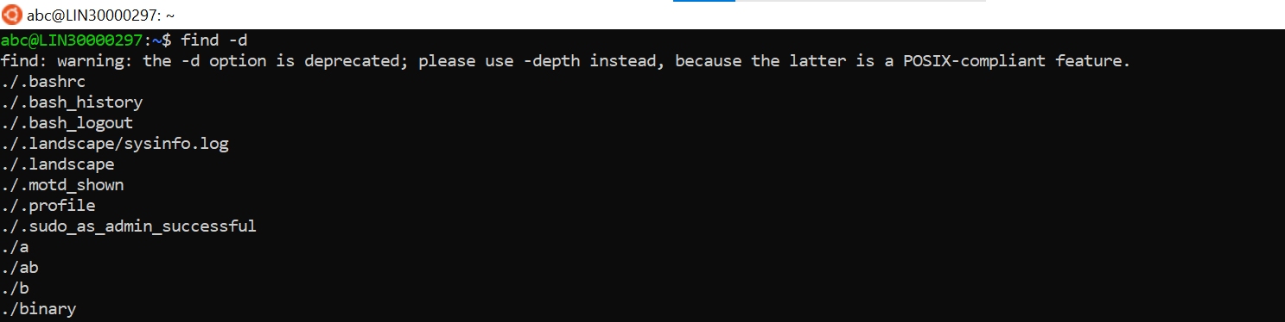

1. Search and display all files with permissions only rw with user and execute permission for others

* **ls -l d1 | grep "^.rw.r....x"**



**Optional Assignments:**

1. Search and copy all files whose size is < 500 bytes to a directory named “backup”

* **Find -size -500c**

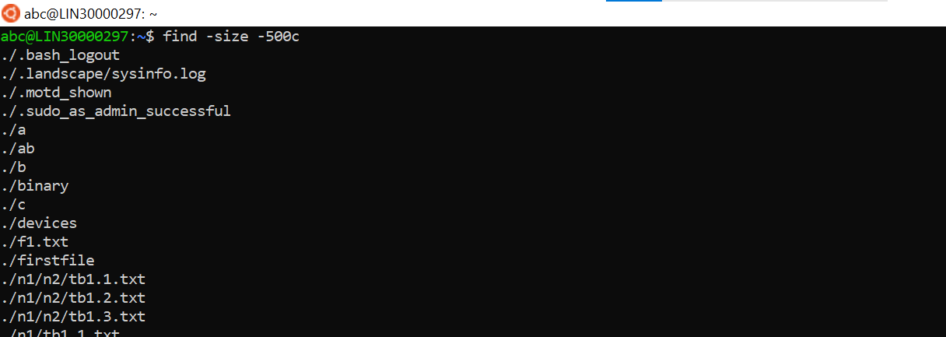

1. Starting from home directory , find and display all
   * 1. empty files

* **find /home -type f -empty**

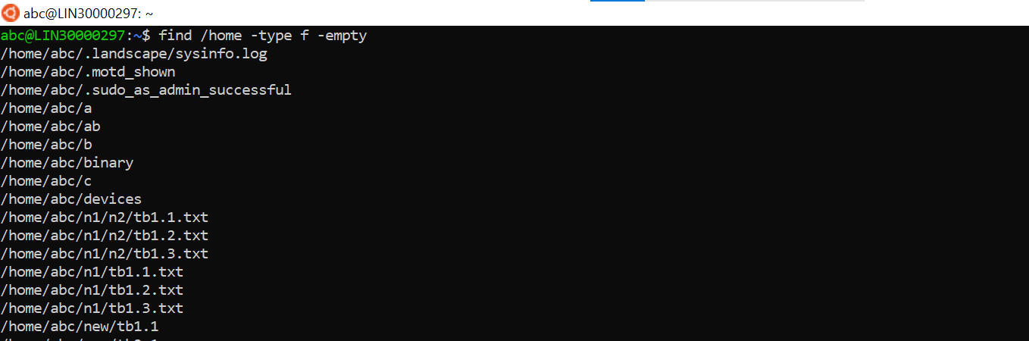

* + 1. readonly files
* **ls -l | grep -e "-r[r-]"**

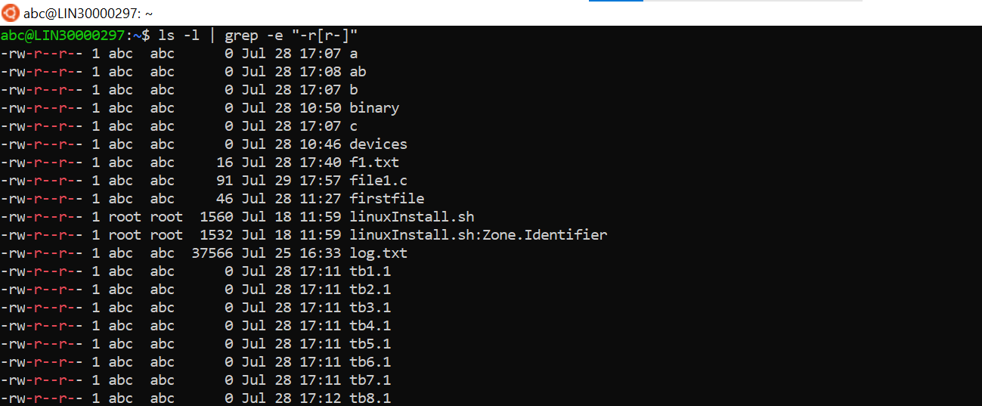

* + 1. all empty directories
* **find /home -type d -empty**



1. Search for a user input pattern in a set of files, extract all lines with the pattern , redirect to a file and display the contents of the file
2. Search and display all files which were modified in last 15 days

* **Find /home/abc -iname “*txt” -mtime -15 -print**

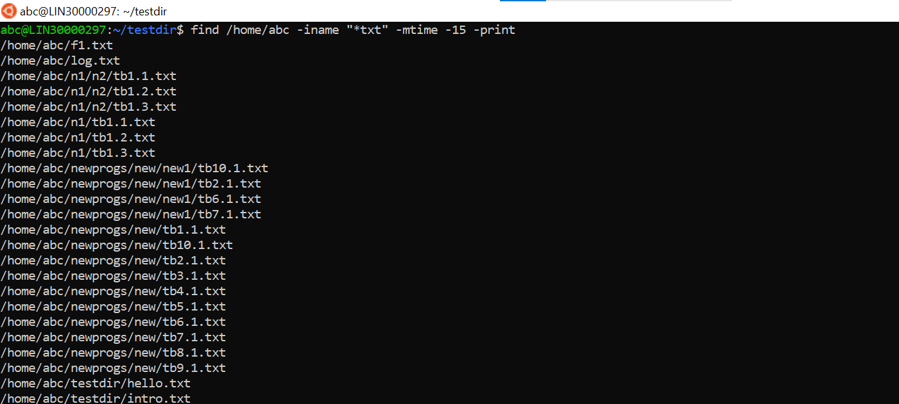

1. Search and display all file which were modified in last 10-15 days

* **Find /home/abc -iname “*txt” -mtime -15 -print**

1. count the number of words in all *.txt files in a directory and display

* **wc -w *.txt**

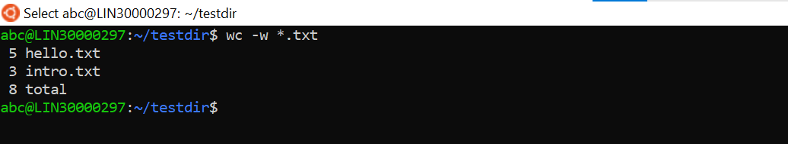

1. In a given directory sort all files based on their size (descending order) and then read and display the contents of each file

* **ls -laS && cat * */\***

